INTEGRATIVE COURSE IN PSYCHOLOGY (ICOPSYCH)

ANALYSIS ON THE RESULT OF PRE-TEST EXAMINATION IN ABNORMAL PSYCHOLOGY
MARCH 22, 2025

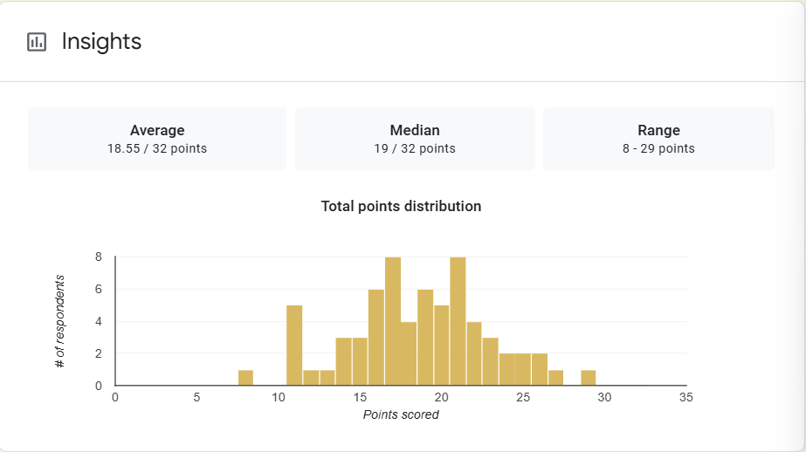

1. Mean Score: The average score across all participants is 18.55 out of 32 points. This suggests that, on average, students performed slightly below the midpoint of the scale. While this score isn't drastically low, it indicates that a significant portion of the participants may have struggled or did not fully grasp the material.

2. Median Score: The median score, which is 19 points, shows that half of the participants scored below 19, and half scored above. This score being slightly higher than the mean (18.55) implies that the distribution of scores is skewed towards the lower end, where some students may have performed significantly worse, pulling the mean lower.

3. Range: The range of scores (from a low of 8 to a high of 29) indicates a substantial variation in student performance. While the highest score of 29 suggests that some individuals performed quite well, the lowest score of 8 indicates that others struggled significantly. This wide range further suggests that the exam may have been challenging for a portion of the group.

Interpretation Summary:

-The performance on the exam shows a moderate overall achievement, with the average score being just above half of the total possible points.

- The median score being slightly higher than the mean suggests that while a significant portion of students did slightly better than average, there was still a notable number who performed below expectations.

- The wide range of scores highlights the varying levels of student understanding or preparation for the exam.

RATIONALIZATION:

DIFFICULT QUESTIONS:

